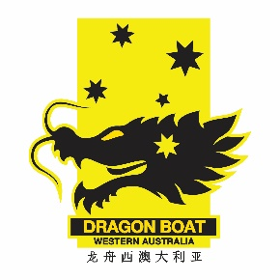

Dragon Boating WA complaints guidance

Dragon Boating WA members are covered by the Australian Dragon Boat Federation Member Protection Policy, available at https://www.ausdbf.com.au/policies/memberprotection/.
Below is a list of the appropriate contacts if you wish to make a complaint related to your participation in dragon boating. In the first instance, you should lodge your complaint at the level at which the issue has occurred (i.e. if it occurred at club level, then it should be initially dealt with at club level; if it’s related to competing for a state or national team for example, direct your complaint to the corresponding authority).

IN ALL CASES
- if the issue relates to a person under 18 years of age contact the Child Protection agency in WA https://www.dcp.wa.gov.au/Pages/Home.aspx
- If issue relates to a criminal offence contact the WA Police Child Protection Unit. https://www.police.wa.gov.au/Your-Safety/Child-Abuse/How-to-report-child-abuse. If the matter is urgent or the safety, health or welfare of a child is at risk then the emergency 000 number must be called.

CLUB/LOCAL ISSUE
Possible first options:
- Member Protection Information Officer
- Club President
- Team Manager, Coach or Captain

Other options
- www.playbytherules.net.au
- Alternative Dispute Resolution organisation
- State/Territory Equal Opportunity Commission
- Department of Mines, Industry Regulation and Safety https://www.commerce.wa.gov.au/consumer-protection

STATE/TERRITORY ISSUE
Possible options:
- Member Protection Information Officer
- State Team Manager, Head Coach or Captain
- www.playbytherules.net.au
- Alternative Dispute Resolution organisation
- State/Territory Equal Opportunity Commission
- Department of Mines, Industry Regulation and Safety https://www.commerce.wa.gov.au/consumer-protection

NATIONAL ISSUE
Possible first options:
- Member Protection Information Officer
- National Chair or CEO
- Australian team Manager, Head Coach or Captain

Other options
- www.playbytherules.net.au
- Alternative Dispute Resolution organisation
- State/Territory Equal Opportunity Commission and/or Australian Human
Rights Commission Australian Sports Commission
- Lawyer (legal advice)

